Uni Agent
How the technology works, and the agents behind it
A personal university assistant that runs on a Windows laptop and talks to its owner on Telegram: Moodle deadlines, lecture and lab summaries, quizzes and a weekly review.
Courses: CSIT205 · CSIT214 · CSCI235 (UOW Dubai)
Version: 8 October 2026

Contents
1. What the Uni Agent is 3
1.1 What it does for the student 3
1.2 At a glance 3
2. How it works: the architecture 4
2.1 The three inputs 4
2.2 The orchestrator 4
3. The agents 5
3.1 Ingest agent 5
3.2 Lecture agent 6
3.3 Lab agent 6
3.4 Deadline agent 6
3.5 Exam agent 6
3.6 Weekly Review agent 7
4. The technology 7
4.1 How the AI is used 8
4.2 Local AI: OCR and speech 8
5. Step by step: four real flows 8
6. Data and storage 9
7. Running in the background and staying reliable 9
8. Privacy, security and academic integrity 10
9. Limits to be aware of 10
10. Glossary 11

1. What the Uni Agent is
The Uni Agent is a small multi-agent system written in Python. It runs quietly in the background on the laptop, watches the places where course material arrives (the Moodle calendar and the course folders on the desktop), and talks to its owner through a private Telegram bot on the phone.
Instead of one large program doing everything, the work is split between an orchestrator and six specialist agents. Each agent has one job and, where it uses AI, its own instructions (its “system prompt”). The orchestrator decides which agent handles each event and is the only part allowed to send messages.

1.1 What it does for the student
- Deadlines: reads assignments, quizzes, labs and exams from the Moodle calendar and sends alerts 7 days, 3 days, 1 day and 3 hours before each one.
- Lecture summaries: turns lecture slides into a TL;DR, key concepts, key terms and likely exam questions.
- Lab briefings: turns lab sheets into objectives, setup, steps, common mistakes, a submission checklist and viva questions, without writing graded answers.
- Quizzes: asks theory or viva-style questions, marks typed or spoken answers, and repeats weak questions more often.
- Weekly review: every Sunday at 18:00, separate Lectures and Labs sections, weakest topics, what is due and three revision tasks.
- Live file record: /files lists every file in the course folders and whether it has been summarised, with buttons to summarise the rest.

1.2 At a glance
Item | Value
Runs on | The student's Windows 11 laptop, started automatically at login (Task Scheduler)
Talks through | Telegram bot (long polling: no server or open ports needed)
Main language | Python 3.13
AI model | Google Gemini free tier (Flash-Lite first, Flash as fallback); switchable to Anthropic Claude
Local AI | Windows OCR for images, faster-whisper for speech (both run on the laptop)
Storage | One SQLite database file plus Markdown summaries on disk
Automated tests | 146 tests covering alerts, routing, OCR, voice, quizzes, outages and more

2. How it works: the architecture
Everything flows the same way: an input arrives, the orchestrator routes it to an agent, the agent does its job using the shared services, and the result goes back to the phone through Notify.
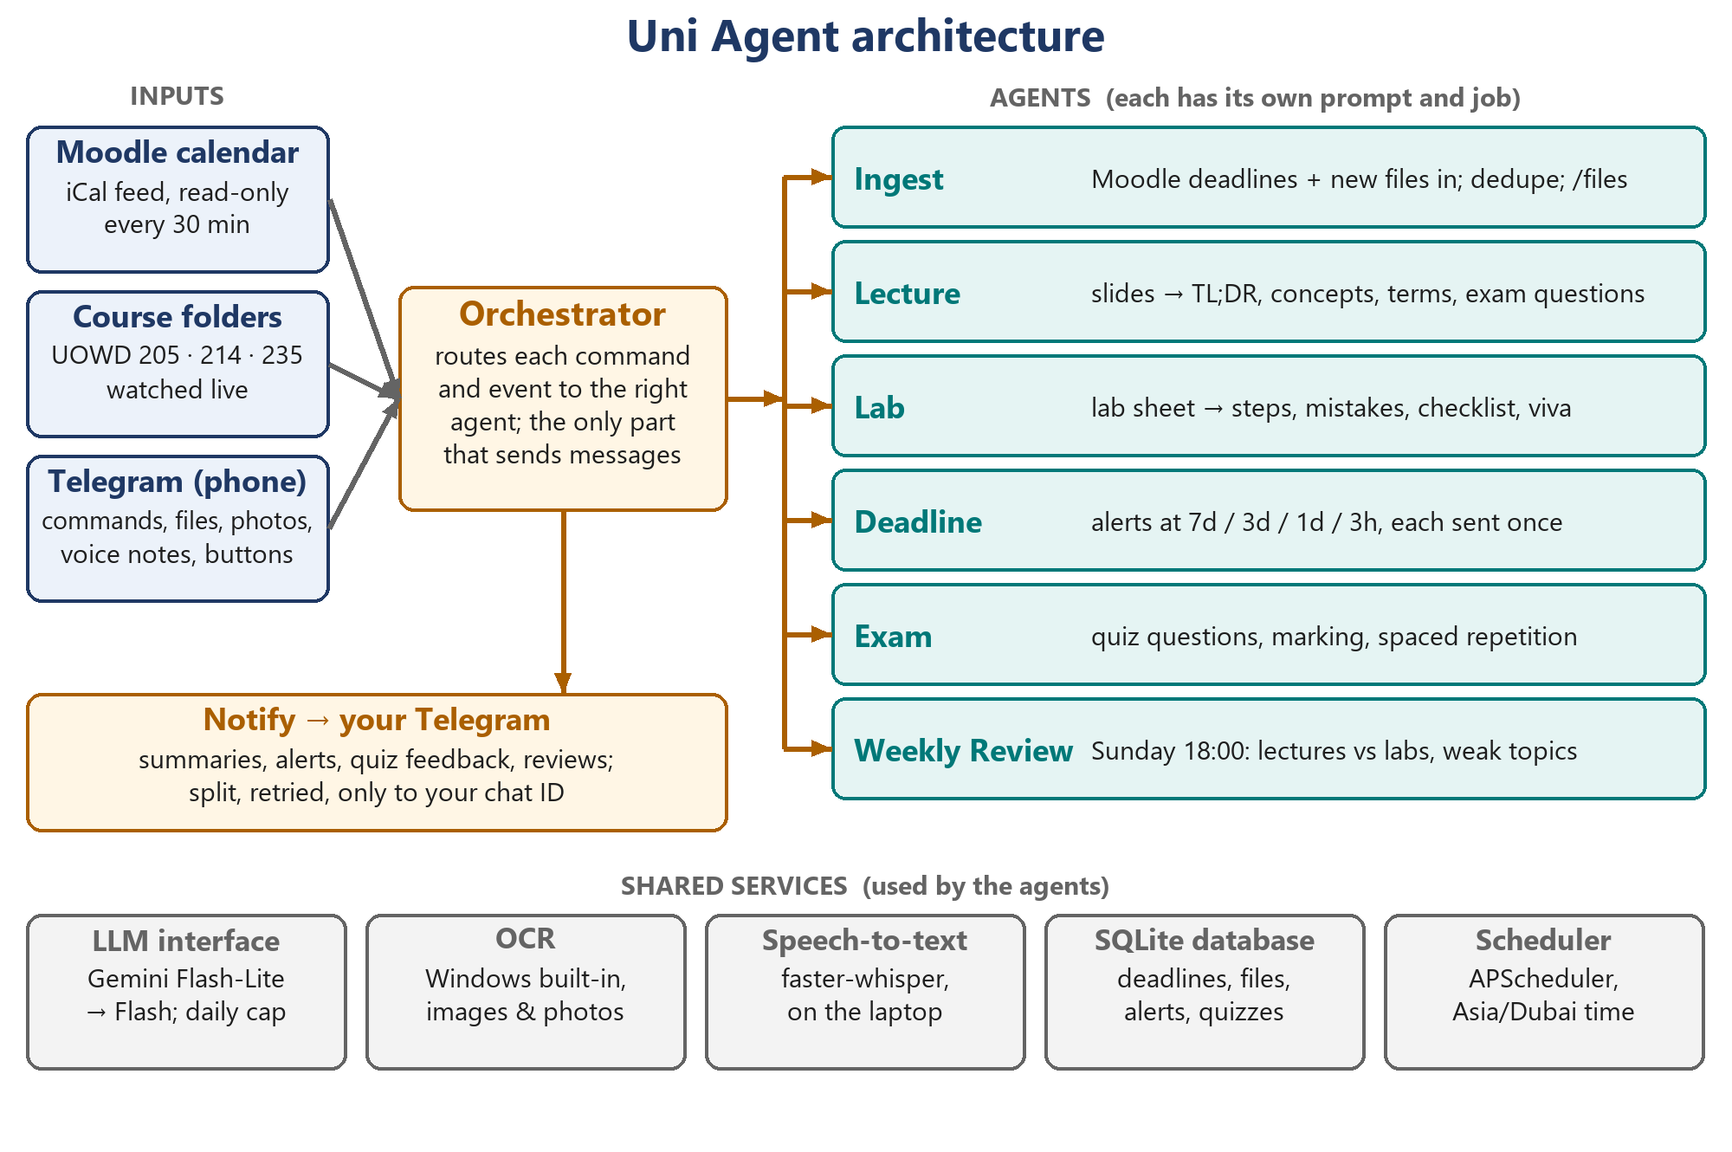
Figure 1. Inputs, the orchestrator, the six agents and the shared services they use.

2.1 The three inputs
Input | How it is read
Moodle calendar | Moodle's own “export calendar” link (an iCal feed). Downloaded every 30 minutes. Read-only: the agent never logs in, never stores a password and never changes anything on Moodle.
Course folders | UOWD\205, \214 and \235 on the desktop. A folder watcher notices new, moved or renamed files within seconds, and a full rescan every 30 minutes catches anything missed while the laptop was off.
Telegram | Commands (/quiz, /files, /week…), files, photos, albums, voice notes and button taps. Only the owner's chat ID is answered; everyone else is ignored.

2.2 The orchestrator
The orchestrator (orchestrator.py) is the switchboard. It is the only component that knows which agent handles what, and, together with Notify, the only one that sends Telegram messages. Its main jobs are:
- Routing documents: lecture files go to the Lecture agent and lab files to the Lab agent. A file inside a labs\ folder always reaches the Lab agent. If the type is unclear, it asks “Lecture or Lab?” with two buttons.
- Running the schedule: Moodle sync and folder rescan every 30 minutes, deadline checks every 15 minutes, the weekly review on Sunday at 18:00.
- Protecting the free AI quota: only one AI job runs at a time, identical files are processed once, and a daily token cap stops all AI calls when reached.
- Holding conversation state: for example, which quiz question is waiting for an answer.

3. The agents
Each agent is a separate Python module with a clear input and output and no direct access to Telegram. Agents that use AI keep their instructions in a SYSTEM_PROMPT constant at the top of the file, so each one behaves differently even though they share the same AI model.
Agent | Job | Input → output | Uses AI?
Ingest | Brings deadlines and documents in: parses the calendar, hashes files, skips duplicates, keeps the live /files record | Calendar feed, files → database rows | No
Lecture | Helps the student understand the theory and prepare for exams | Lecture text → summary | Yes
Lab | Helps the student get the practical done themselves, and understand it | Lab sheet text → briefing | Yes
Deadline | Decides which alerts are due and formats deadline lists | Deadlines + time → alerts | No
Exam | Writes questions, marks answers, schedules repetition | Summaries, answers → questions, marks | Yes
Weekly Review | Builds the Sunday review | Week's activity → review | No

3.1 Ingest agent
The Ingest agent is the front door. It has three parts:
- Moodle calendar ingest: downloads the iCal feed, keeps real deadlines (skipping “Quiz opens” events), turns course codes such as CSIT205_DB426 into CSIT205, treats all-day events as due at 23:59 Dubai time, and stores each one with its unique Moodle ID. If Moodle moves a deadline, its alerts are reset to follow the new date.
- Document ingest: every file is fingerprinted with a SHA-256 hash, so the same content is never processed twice, even under a different name. It decides lecture or lab from a lectures\ or labs\ folder, then from the filename (lab, tutorial, practice… versus lecture, L01, slides…). Files containing the student’s ID (their own submissions) are always ignored.
- Live file record (/files): reads the course folders from disk on every request, so renames and deletions show immediately, and joins each file with what the agent knows: summarised, waiting, here before the bot, ignored and so on.
On the first run it marks files that were already in the folders as “seen” without summarising them, so the free AI quota isn't used up all at once. They can be summarised later from /files.

3.2 Lecture agent
Goal: understand the theory. The agent reads the text extracted from slides or notes and replies in a fixed format:
Section | What it contains
TL;DR | 2–3 sentences on what the lecture is about and why it matters
Key concepts | 5–8 bullets, each one idea explained simply
Key terms | 6–12 terms with short definitions
How it connects | Links to earlier lectures in the same course
Likely exam questions | 5 questions, mixing recall and application
It is given the titles of earlier lectures in the same course, so it can say how the new one connects. Lectures are sent to the AI in one request where possible, which is about 20 to 25 thousand tokens for a 60-slide deck. Only very long documents are split into parts, summarised part by part, and then combined.

3.3 Lab agent
Goal: get the practical done and understand it. Its output is a briefing with: objective, what to set up before starting, condensed steps, what a working result looks like, common mistakes, a submission checklist (using Moodle deadlines when the sheet doesn't give a date) and five viva questions.
Academic integrity rule (built into the Lab agent's instructions)
The Lab agent never writes the graded answers, final code, SQL queries, diagrams or report text that a lab asks for.
It names the concept, command or syntax to use and explains what it does. For question sheets it gives hints, not answers. Tested on a real PL/SQL lab: it named SELECT INTO, %TYPE and CASE without writing any of the code.

3.4 Deadline agent
Every 15 minutes the Deadline agent checks each upcoming deadline against four alert points: 7 days, 3 days, 1 day and 3 hours before it is due. Each alert is recorded in the database the moment it is sent, so it is never sent twice, even across restarts.
- Late discovery: if a deadline is first seen with only 2 days left, only the “3 days” alert is sent, not a burst of old ones.
- Time zones: all times are stored in UTC and shown in Dubai time, so “3 hours before 23:59 Dubai” is always exact.
- Outages: an alert is only marked as sent after Telegram confirms it, so a network drop delays an alert but never loses it.
Example alert: “[CSIT205] Week 3 Lab 2 Submission Box is due in 4 days (Sun 11 Oct, 23:55)”, marked as a lab item with a clock and test-tube icon on the phone.

3.5 Exam agent
The Exam agent runs quizzes from the stored summaries. /quiz lectures gives theory questions; /quiz labs gives practical, viva-style questions (“Why did we use…?”, “What would happen if…?”).
- Questions are generated once per document (8 each) and saved, so later quizzes cost nothing.
- Each answer, typed or spoken, is marked by the AI as correct, partly correct or wrong, with a short explanation and, when needed, the model answer.
- Spaced repetition with Leitner boxes: correct moves a question up a box (asked again in 2, 4, 8 or 16 days); wrong sends it back to box 1 (asked again tomorrow).
- Every answer is logged by topic, which is how the weekly review finds weak topics.

3.6 Weekly Review agent
Every Sunday at 18:00 (or on demand with /week) this agent builds a review with separate Lectures and Labs sections: what was covered, quiz accuracy, and weakest topics. Then it lists what is due in the next 7 days and suggests three revision tasks. It is deliberately rule-based (no AI), so it is free, instant and predictable. Every suggestion ends with the exact command to run.

4. The technology
Part | Technology | Why it was chosen
Language | Python 3.13, virtual environment | Simple, well supported, good libraries for every task here
Phone link | python-telegram-bot (long polling) | Works from a laptop with no server, domain or port forwarding
Scheduling | APScheduler | Runs the 15-minute, 30-minute and Sunday jobs inside the app, in Dubai time
Storage | SQLite (built into Python) | One file, no database server; enforces rules such as “each alert once”
Moodle | icalendar + httpx | Reads the calendar export link; no login or password needed
Folder watching | watchdog | Instant notice of new or renamed files in the course folders
Documents | pypdf, python-pptx, python-docx | Extract text from PDF, PowerPoint and Word files
AI (text) | Google Gemini via google-genai; Anthropic Claude as an option | Free tier for a student; one config line switches provider
OCR | Windows built-in OCR (winrt) | Reads image-only slides and photos locally, free, nothing to install
Speech-to-text | faster-whisper (base.en model) | Transcribes voice notes on the laptop; audio never leaves it
Config | pydantic + python-dotenv + YAML | Settings in config.yaml; secrets only in .env
Background running | Windows Task Scheduler + pythonw | Starts hidden at login and relaunches within 10 minutes if it stops
Testing | pytest (146 tests) | Checks the risky parts automatically

4.1 How the AI is used
All AI calls go through one small LLM interface (llm.py). The agents ask it for text and do not care which provider answers. This keeps the system simple and makes the provider a one-line setting.
- Model fallback: Gemini Flash-Lite is tried first because it is fast and usually available; if it is overloaded, Gemini Flash is tried next.
- Daily cap: every call's tokens are counted per day; at 400,000 tokens all AI work pauses until midnight.
- Free-tier awareness: the free tier allows roughly 20 requests a day, so documents are sent in one request, questions are generated once and reused, and the weekly review uses no AI at all.
- Marked inputs: text from OCR or speech is labelled so the AI expects small recognition errors and doesn't repeat them.

4.2 Local AI: OCR and speech
Two kinds of AI run entirely on the laptop, so images and audio are never uploaded:
- OCR reads slides that are just pictures (all three CSCI235 decks were screenshots), scanned PDFs and photos sent in Telegram. It only runs on slides with almost no real text, at about 0.3 seconds per image.
- Speech-to-text turns voice notes into text in about a second for a short note. During a quiz a voice note is treated as the answer; otherwise it is summarised like a document.

5. Step by step: four real flows

A. A new lecture file appears in a course folder
- The folder watcher sees the file and waits until its size stops changing (it is still being saved).
- Ingest hashes it; if the same content was seen before, it stops here.
- The orchestrator decides the type (folder, then filename, else asks) and sends it to the Lecture agent.
- Text is extracted from the PDF or PowerPoint; image-only slides go through OCR.
- The Lecture agent sends one request to Gemini with its own instructions and the earlier lecture titles.
- The summary is saved under data\summaries\lectures\<course>\ and sent to the phone.

B. A deadline alert
- Every 30 minutes the Moodle calendar is downloaded and new or moved deadlines are stored.
- Every 15 minutes the Deadline agent checks which alert points have been reached and not yet sent.
- The orchestrator sends the alert; only after Telegram confirms it is the alert recorded as sent.

C. Answering a quiz question by voice
- /quiz lectures normalization picks the matching summaries; questions are generated once if needed.
- A voice note arrives while a question is waiting; it is transcribed on the laptop.
- The bot shows “I heard: …”, the Exam agent marks the answer, the Leitner box is updated, and the next question follows.

D. An album of photos of printed notes
- Telegram delivers each photo separately; the bot collects them until no new photo has arrived for 3 seconds and every download has finished.
- Each photo is read with OCR; together they become one text document (one AI request, not one per page).
- A caption such as “/lecture 235 Week 3 board” sets the type, course and title; without one, the bot asks Lecture or Lab.

6. Data and storage
Everything the agent remembers lives in one SQLite file (data\uni.db) plus readable Markdown copies of every summary.
Table | What it holds
items | Deadlines from Moodle: course, title, type, due time, Moodle ID
documents | Every file seen: content hash, lecture or lab, course, status (summarised, waiting, here before the bot…), summary location
alerts_sent | Which alert (7d, 3d, 1d, 3h) was sent for which deadline, which makes duplicates impossible
quiz_questions | Generated questions with model answers, topic, Leitner box and next due date
quiz_log | Every answer and its score; used to find weak topics
llm_usage | Tokens used per day, for the daily cap and /status
kv | Small settings such as the last sync time and the last problem

7. Running in the background and staying reliable
- Auto-start: a Task Scheduler task starts the agent hidden at login, and relaunches it within 10 minutes if it ever stops. This was verified with a real restart.
- One copy only: a lock file stops a second copy from starting, so two bots never compete for Telegram.
- Network drops and sleep: Telegram messages are retried with increasing waits; the bot reconnects on its own. This was verified by switching Wi-Fi off and on.
- Error alerts: real problems (a crashed job, Moodle unreachable three times in a row) are sent as warning messages, at most once an hour per kind; expected blips are only logged.
- Logs: logs\uni_agent.log rotates at 1 MB and keeps five files; it never contains tokens or private links.
A real bug, found and fixed
When voice support was added, the first voice note crashed the agent. The Windows OCR package ships an old copy of a Microsoft C++ runtime file (MSVCP140.dll, version 14.29); the speech engine needed a newer one and crashed when it got the old copy.
Fix: the agent now loads Windows' own newest copy (14.50) first, so every component shares it. An automated test reproduces the crash without the fix and passes with it.

8. Privacy, security and academic integrity
Rule | How it is enforced
Read-only toward Moodle | Only the calendar export link is read. No login, no password, no posting or submitting.
Only the owner | The bot answers a single Telegram chat ID; all other chats are ignored and logged.
Secrets stay secret | Bot token, API key and calendar link live only in .env, which is never committed or logged; error messages strip URLs.
Local by default | Files stay on the laptop. Images (OCR) and audio (speech) are processed locally; only extracted text goes to the AI.
AI provider privacy | On Gemini's free tier, Google may use submitted text to improve its products. The student checks the university's AI policy.
Academic integrity | The Lab agent explains and guides but never produces submission-ready answers, code or reports; the student’s own submissions are never processed.

9. Limits to be aware of
- The agent only runs while the laptop is on and awake. Alerts due during sleep arrive when it wakes. A small always-on device (for example a Raspberry Pi) would remove this limit.
- The Moodle calendar lists deadlines, not lecture files. Moodle's file web service is not available at UOW (there is no mobile web-service key), so files come from the course folders and Telegram uploads.
- Gemini's free tier allows about 20 requests a day; summaries, quiz generation and each marked answer use one.
- OCR handles printed text and slides well but not handwriting; the speech model is English-only by default.
- Summaries and quiz marking are study aids and can be wrong; check them against the slides.

10. Glossary
Term | Meaning
Agent | A module with one job and, if it uses AI, its own instructions
Orchestrator | The coordinator that sends each event to the right agent
System prompt | The fixed instructions that shape how an AI-based agent responds
LLM | Large language model, the text AI (here Gemini, or Claude)
Token | A small piece of text that AI usage is measured in; roughly 4 characters
iCal feed | A standard calendar link; Moodle uses it to export deadlines
OCR | Optical character recognition: reading text from images
Hash (SHA-256) | A fingerprint of a file's content, used to spot duplicates
Leitner boxes | A spaced-repetition method: known questions come back less often
Long polling | The bot repeatedly asks Telegram for new messages, so no public server is needed

